Acceptance tests   
“Acme Rookies v1.0”

|  |  |
| --- | --- |
| Development team | |
| **Identifier** | *G92* |
| **Members** | *Batista Núñez, Francisco.*  *de la Flor Bonilla, Álvaro.*  *Fernández Benjumea, Carmen.*  *Ferrete Molle, José Antonio.*  *Salvat Pérez, Antonio Manuel.*  *Sanchez Hipona, Antonio.* |
| **Testing team** | |
| **Identifier** |  |
| **Members** |  |
| **Indexing data** | |
| **Test designers** | *de la Flor Bonilla, Álvaro.*  *If you need to contact me:*  *alvarodelaflor@gmail.com*  *+34 665 381 121* |
| **Testers** |  |
| **Notes** | *Use cases of R3* |

**Table of contents**

Use case 3.1.1: Logged as auditor, list and show positions. Also uses the integrated browser. 3

Use case 3.2.1: Logged as auditor and list the audits 6

Use case 3.2.2: Show audits. 10

Use case 3.2.3: Logged as auditor, create or edit an Audit 15

Use case 3.2.3: Logged as auditor, delete an Audit 19

# Use case 3.1.1: Logged as auditor, list and show positions. Also uses the integrated browser.

Description

An user logged as an auditor must be able to list the assignable positions to audit. An auditor can only create an audit to positions that still don’t have an audit created by him.

Preconditions

The shown views are based on the Populate Data.

Access

Log in to the system with an existing user.

**Homepage > Header Menu > Login**

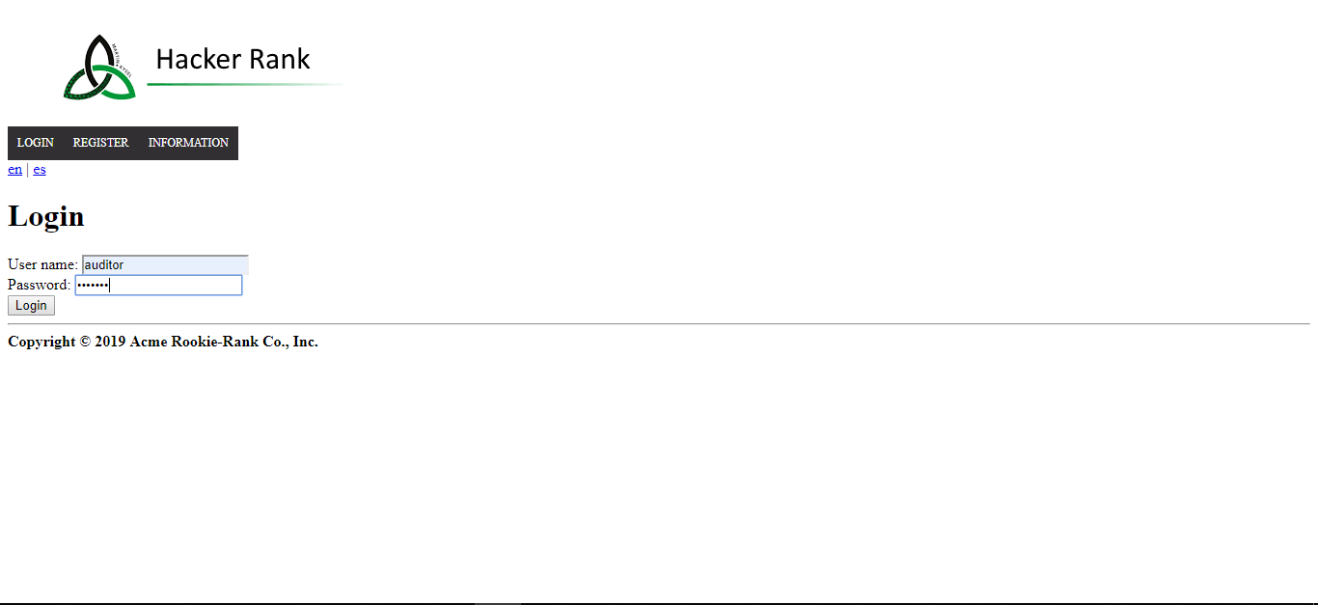

Login as “auditor/auditor”

Browse through the available positions. Use the search form.

> Header Menu > Display the "INFORMATION" options > List about positions

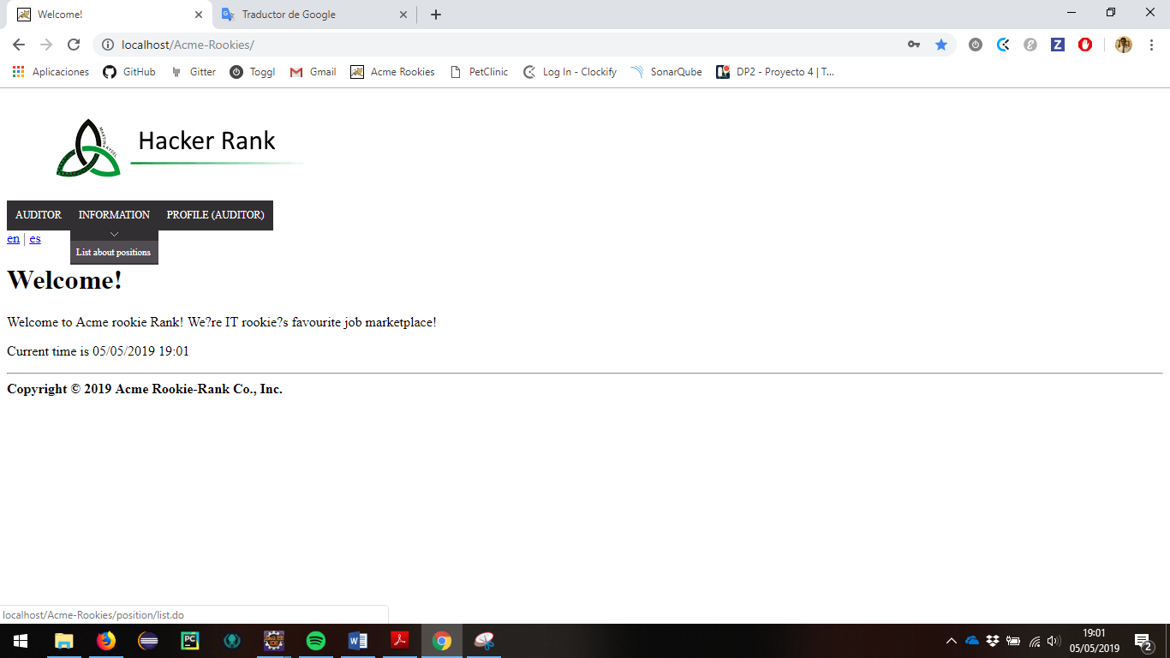

The list of positions to audit will be displayed

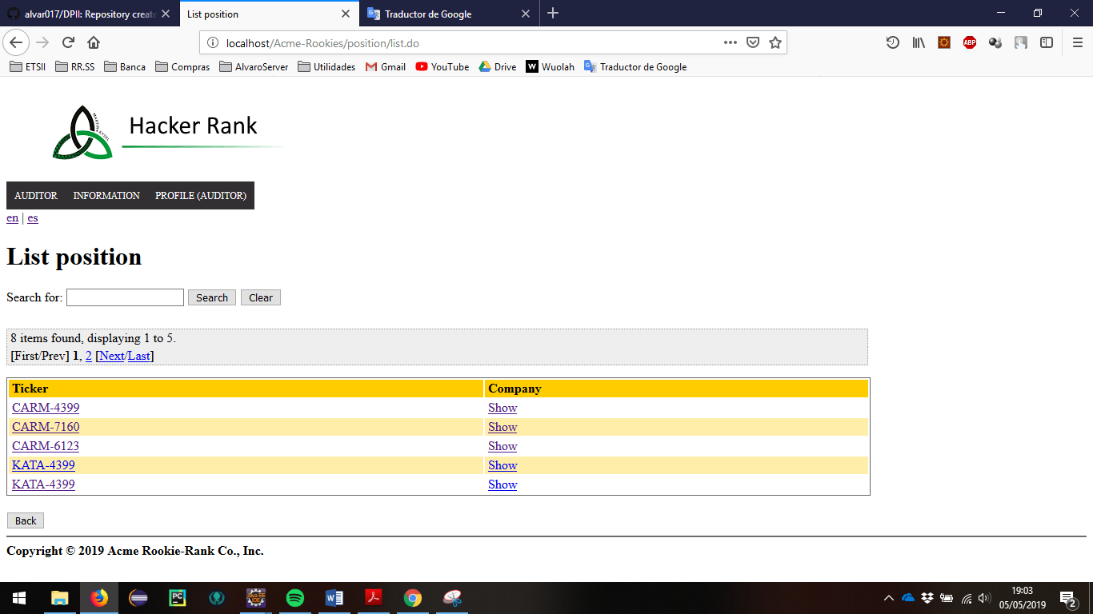

Use the browser.

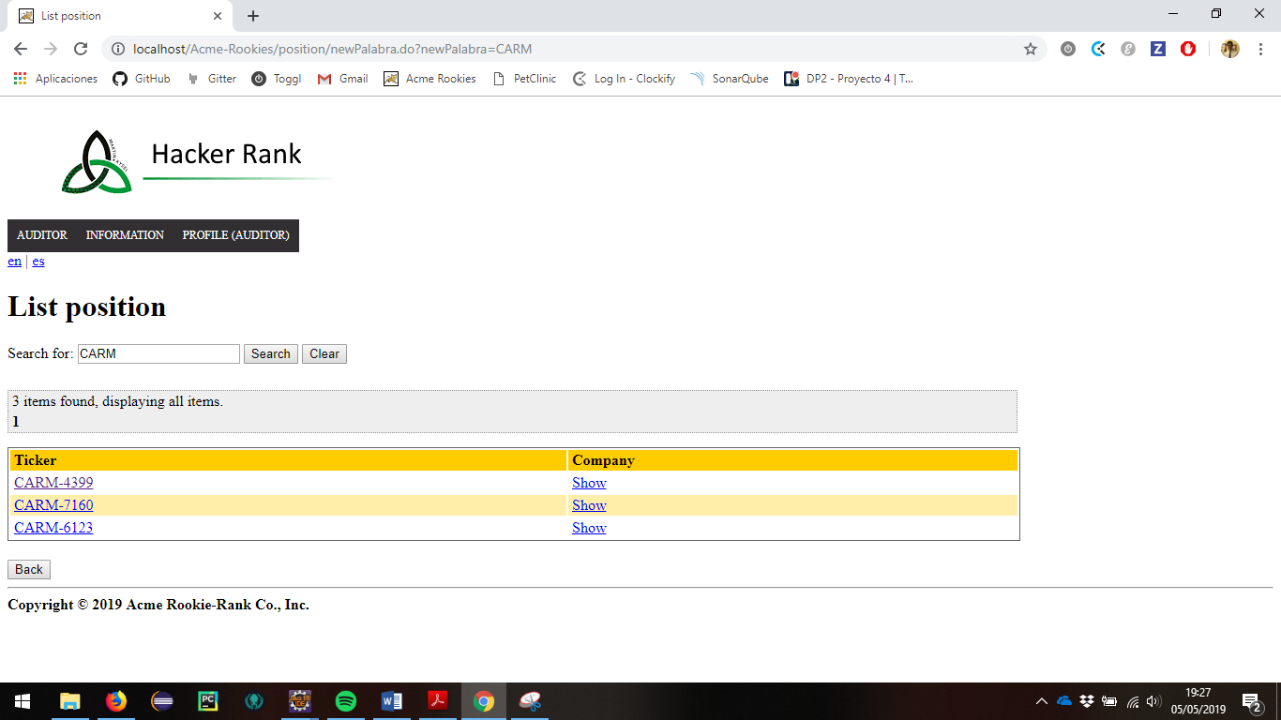

Tests

|  |  |
| --- | --- |
| Test 1 | |
| **Description** | *We must be able to see the list of position that doesn’t have an audit created by the logged Auditor yet.* |
| **Expected** | *A paged list with 6 position will appear. In the list should appear 2 columns, Ticker and Company with the respective values, the ticker in the first case and a link to the Company in the following.* |
| **Outcome** |  |
| **Notes** |  |

*No additional tests are required for this use case since they are evaluated in depth in another section. You simply want to verify that the logged-in user continues to maintain access to this functionality.*

# Use case 3.2.1: Logged as auditor and list the audits

Description

A logged-in auditor can list all their audits, both those that are in the final state and those that are in draft status. However, any other user can only see the audits belonging to another auditor that are in the final state, discarding in this case those that are in draft status.

Access

First, the user must log as auditor in the login page. User: auditor, Password: auditor

The steps to follow are explained above.

**

Go to the section of the audit list.

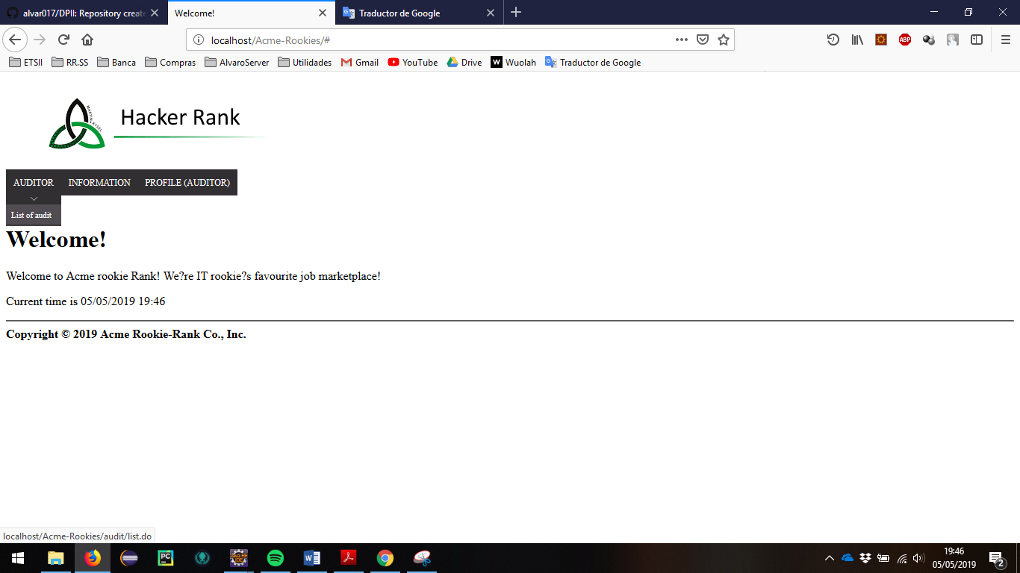

> Header Menu > Display the "AUDITOR" options > List of audits

Then all the audits that have been created are displayed, grouped by final status and draft status.

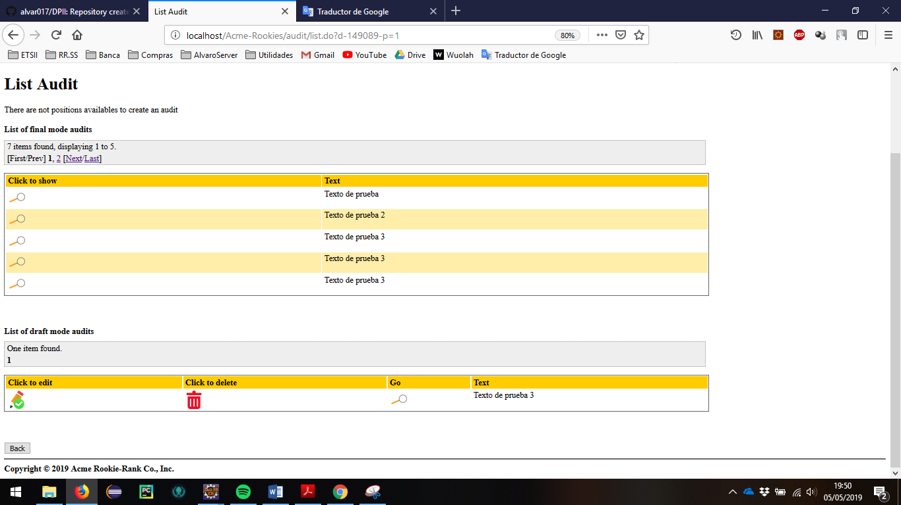

Tests

|  |  |
| --- | --- |
| Test 1 | |
| **Description** | *As a logged-in user (auditor / auditor), the list of audits is displayed after following the previous steps.* |
| **Expected** | All audits in this view must belong to the auditor.  They should show themselves grouped by their state. In the case that it is in draft status, in addition to appearing the option to show should appear the option to delete and edit.  Audits in the final state must make references to positions in the final state that have not been canceled.  In our case, as there are no possible positions to be audited, the button to create a new audit cannot appear. |
| **Outcome** |  |
| **Notes** |  |

|  |  |
| --- | --- |
| Test 2 | |
| **Description** | Pagination links must work correctly. |
| **Expected** | When the list of audits that belong to the auditor is displayed, the paging links should allow the user to navigate to the next, previous, first and last page. Paging will also allow the user to select a specific page by selecting the number of that page. |
| **Outcome** |  |
| **Notes** |  |

|  |  |
| --- | --- |
| Test 3 | |
| **Description** | Correct internationalization of all messages. |
| **Expected** | If audits cannot be created (because there is no more available position), as well as in all the headers, the messages must appear personalized according to the selected language. |
| **Outcome** |  |
| **Notes** |  |

|  |  |
| --- | --- |
| Test 4 | |
| **Description** | Non-logged-in users can see a list of audits grouped by auditor. |
| **Expected** | When a user does not log list an auditor audits should only appear those who are in final state. Likewise, only the set of these audits should appear in the final state, avoiding those buttons to create a new audit or division headings by type of audit status.  Deslogue and use /Acme-Rookies/audit/list.do?auditorId=75 |
| **Outcome** |  |
| **Notes** |  |

|  |  |
| --- | --- |
| Test 5 | |
| **Description** | An actor logged in as an auditor can also view the list of audits of another auditor as previously done. |
| **Expected** | Log in as another auditor (register as one in case you have not done it yet). Go back to /Acme-Rookies/audit/list.do?auditorId=75 and check that the resulting page is similar to the one not logged in; The button to create a new audit or the final / non-final audit headers should not appear. |
| **Outcome** |  |
| **Notes** |  |

|  |  |
| --- | --- |
| Test 6 | |
| **Description** | The Back button must return to the home page, whether a user is logged in or not. |
| **Expected** | Whatever the previous action, the back button should return to the welcome page. |
| **Outcome** |  |
| **Notes** |  |

# Use case 3.2.2: Show audits.

Description

Both a logged-in user and a non-logged-in user have access to the sample view of an audit as long as this audit is in final mode, in the case of a draft mode only its creator can view it.

Access

First, the user must log as auditor in the login page. User: auditor, Password: auditor

The steps to follow are explained above.

**

Go to the section of the audit list.



> Header Menu > Display the "AUDITOR" options > List of audits

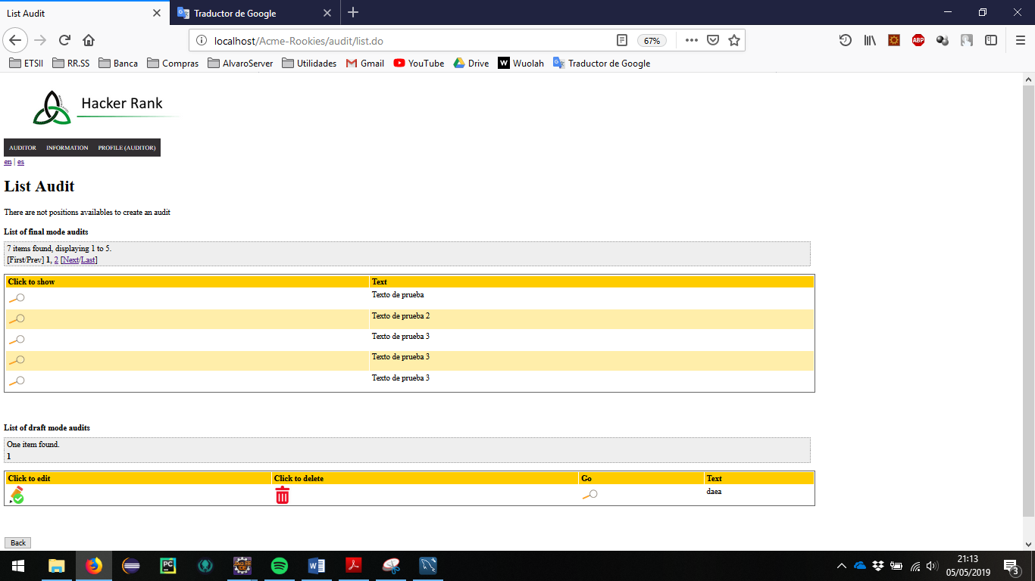

According to the initial configuration assigned, 7 audits in final mode and 1 audit in draft mode must appear.

To see the information of an audit in final mode we must click on the magnifying glass of the first block, in case of wanting to see an audit in draft mode we will press in the magnifying glass of the second block.

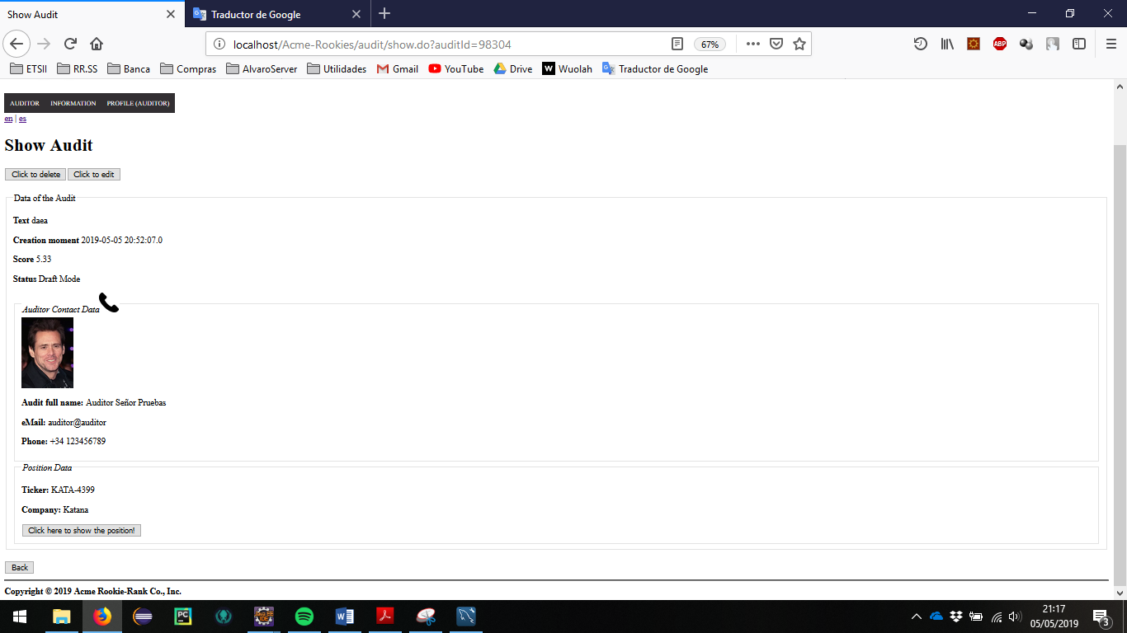

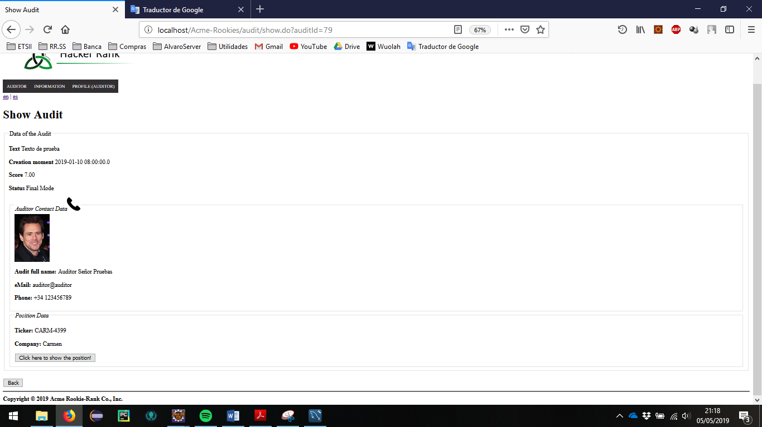

The resulting view should be like the previous one, in the case that it is draft mode in the first case, or final mode in the second case.

Tests

|  |  |
| --- | --- |
| Test 1 | |
| **Description** | *Showing an audit in final mode.* |
| **Expected** | *Check that you have access to an audit in final mode and it is displayed correctly. If the result is positive, copy the link, deslogueate and verify that you still maintain access to that audit by repeating the previous check process.*  *No edit or delete button should appear.*  *(For auditor/auditor -> Acme-Rookies/audit/show.do?auditId=79)* |
| **Outcome** |  |
| **Notes** |  |

|  |  |
| --- | --- |
| Test 2 | |
| **Description** | *Showing an audit in draft mode.* |
| **Expected** | *Check that you have access to an audit in draft mode and it is displayed correctly. If the result is positive, copy the link, deslogueate and verify that you do not continue to maintain access to that audit.*  *In the case that the logged-in auditor is the creator of the audit, both the edit and deletion buttons must appear.*  *For auditor/auditor ->Acme-Rookies/audit/show.do?auditId=84* |
| **Outcome** |  |
| **Notes** |  |

|  |  |
| --- | --- |
| Test 3 | |
| **Description** | *Correct internalization of messages.* |
| **Expected** | *When an audit is shown to a client all messages must be displayed in the language selected by the client. Special emphasis on the status of the audit (monitor that its status is shown semantically instead of returning the Boolean value), the redirection buttons, button to return to the previous page, edit or delete action buttons ...* |
| **Outcome** |  |
| **Notes** |  |

|  |  |
| --- | --- |
| Test 4 | |
| **Description** | *Correct redirection of the action buttons.* |
| **Expected** | *There are 3 types of main buttons in this view, the edit button, the delete button and the display button of the associated position.*  *Ensure that each button performs its action. In the case of deletion, you must redirect to the list of the logged in auditor.*  *Show the associated position, edit an audit and delete an audit respectively.* |
| **Outcome** |  |
| **Notes** |  |

# Use case 3.2.3: Logged as auditor, create or edit an Audit

Description

An user logged as Auditor must be able to edit his audits, which includes creating, editing and deleting them. An audit can be updated or deleted as long as it’s saved in Draft Mode.

Access

First, the user must log as auditor in the login page. User: auditor, Password: auditor

The steps to follow are explained above.

**

Go to the section of the audit list.



> Header Menu > Display the "AUDITOR" options > List of audits

In the case that they are in position to perform an audit, the creation button will appear.

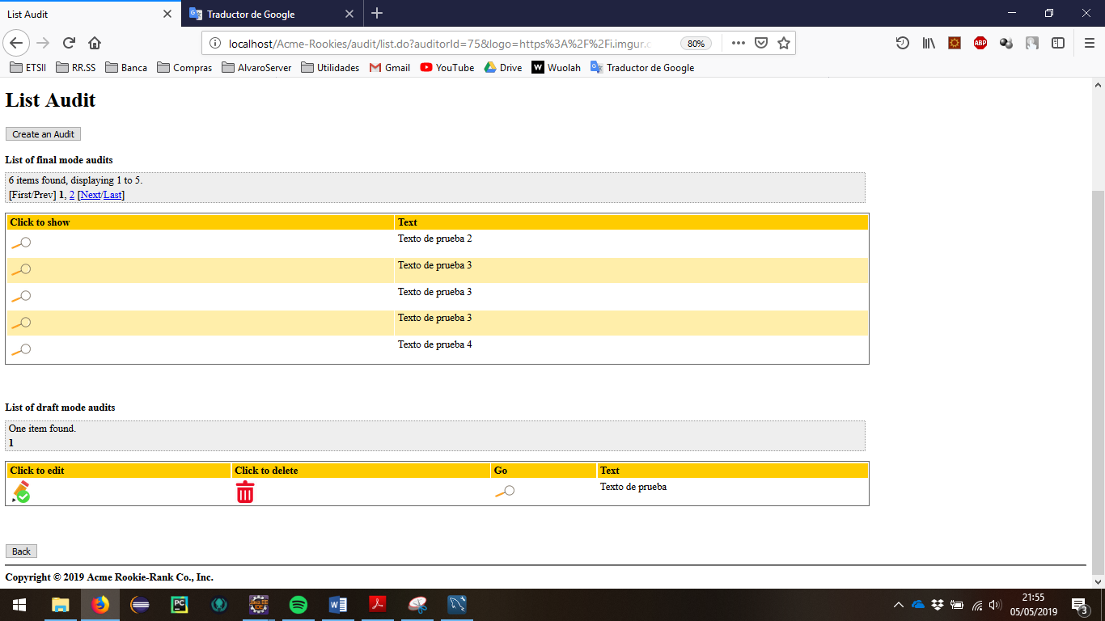

Otherwise, the button does not appear, but in both cases if there are audits in draft mode, the options to edit and delete will appear.

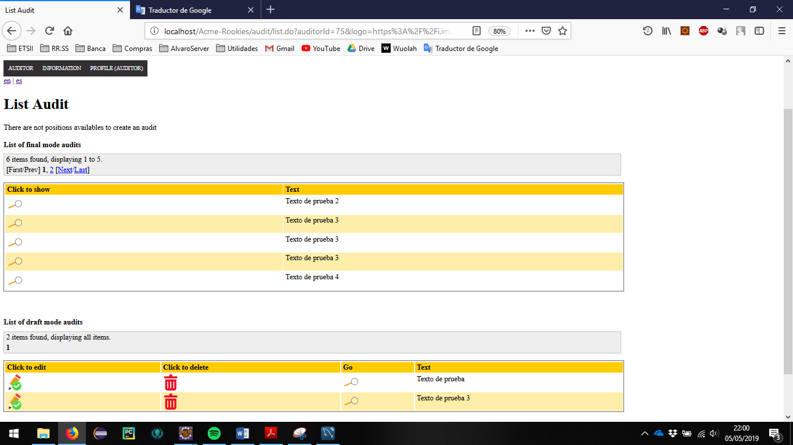

When we create an audit (after clicking on the create button) we should see a form such as the following in which all its parameters are mandatory.

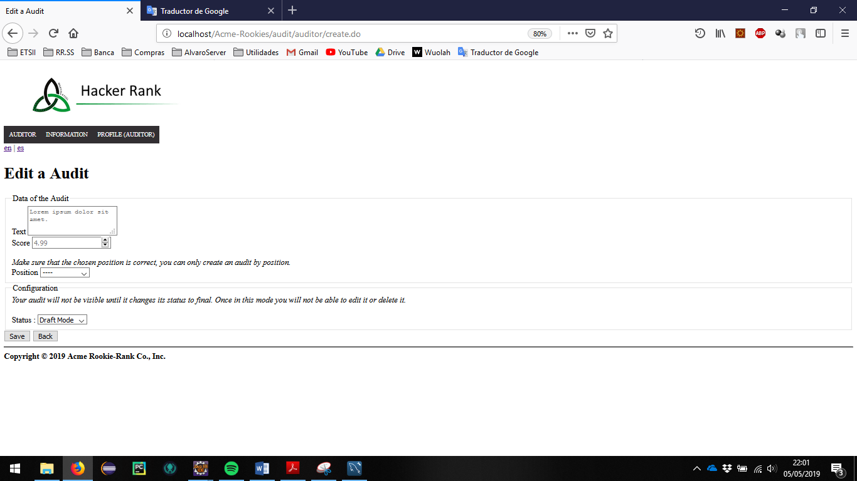

In the case that we edit the screen it is the same, but it inherits the data of the audit to be edited.

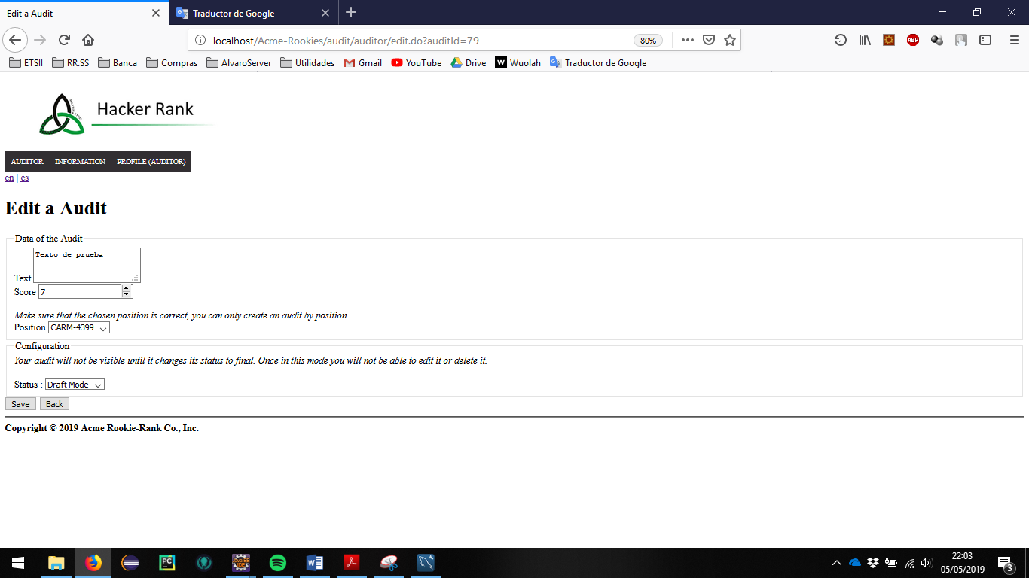

Tests

|  |  |
| --- | --- |
| Test 1 | |
| **Description** | Insert valid data in the form, the user must provide a description text (for example “newDescription1”), select a draft mode and insert a score between 0.00 and 10.00.  If all positions already have an associated audit, delete any audit in draft mode. |
| **Expected** | The user will be redirected to the show of this audit (/audit/show.do?auditId=XXXXX). The options for deleting and editing the audit must be available. The back button should redirect to the list of audits and this new audit should appear in the draft mode block. |
| **Outcome** |  |
| **Notes** |  |

|  |  |
| --- | --- |
| Test 2 | |
| **Description** | The user must edit the previous audit by changing, for example, the position. It was indicated that it should be created in draft mode.  If necessary because there are no available positions and all audits are in final mode, create a new user. |
| **Expected** | After being redirected to the show view the user can click on the edit button from the audit show or return to the list of audits, find his edited audit and click on the edit button. The position associated with the older audit should be available again. |
| **Outcome** |  |
| **Notes** |  |

|  |  |
| --- | --- |
| Test 3 | |
| **Description** | The user tries to edit one of his audits in Final Mode by inserting it id in the URL (GET hacking) |
| **Expected** | If the logged-in actor is an auditor, he will be redirected to the list of his audits, otherwise he will be redirected to the welcome page. |
| **Outcome** |  |
| **Notes** |  |

|  |  |
| --- | --- |
| Test 4 | |
| **Description** | The user provides a blank description. |
| **Expected** | The audit won’t be updated and a message indicating that the description cannot be blank will be shown. |
| **Outcome** |  |
| **Notes** |  |

|  |  |
| --- | --- |
| Test 5 | |
| **Description** | The user provides a null score. |
| **Expected** | The audit won’t be updated and a message indicating that the score cannot be null will be shown. |
| **Outcome** |  |
| **Notes** |  |

|  |  |
| --- | --- |
| Test 6 | |
| **Description** | The user provides a score that is out of range (bigger than 10 or smaller than 0). |
| **Expected** | The audit won’t be updated and a message indicating that the score must be in the range between 0 and 10 will be shown. |
| **Outcome** |  |
| **Notes** |  |

|  |  |
| --- | --- |
| Test 7 | |
| **Description** | The user modifies the html code of the page by modifying the value of the attributes (score-> String, status-> null ...) |
| **Expected** | A commit error message appears when saving, the html page must return to the previous values and if correct values are inserted, you must save. |
| **Outcome** |  |
| **Notes** |  |

|  |  |
| --- | --- |
| Test 8 | |
| **Description** | The user modifies the html page and inserts in the id of the position one associated with another audit. |
| **Expected** | A commit error message appears when saving, the html page must return to the previous values and if correct values are inserted, you must save. |
| **Outcome** |  |
| **Notes** |  |

|  |  |
| --- | --- |
| Test 9 | |
| **Description** | The user tries to edit one of the audit of another auditor user by inserting it id in the URL (GET hacking)  *Create an auditor and a audit if it is necessary.* |
| **Expected** | *System redirects to the welcome page.* |
| **Outcome** |  |
| **Notes** |  |

# Use case 3.2.3: Logged as auditor, delete an Audit

Description

An user logged as Auditor must be able to edit his audits, which includes creating, editing and deleting them. An audit can be updated or deleted as long as it’s saved in Draft Mode.

Access

First, the user must log as auditor in the login page. User: auditor, Password: auditor

The steps to follow are explained above.

**

Go to the section of the audit list.



> Header Menu > Display the "AUDITOR" options > List of audits

In the case that they are in position to perform an audit, the creation button will appear.



Otherwise, the button does not appear, but in both cases if there are audits in draft mode, the options to edit and delete will appear.



Tests

|  |  |
| --- | --- |
| Test 1 | |
| **Description** | Once the user is in the list view, must click on the red bin of the audit list in draft mode.  If there is no draft audit you must create one as was done previously. |
| **Expected** | The system must redirect in view of the list of audits, in which the deleted audit should no longer be present.  If a new audit is created, the position associated with the deleted audit must be available again. |
| **Outcome** |  |
| **Notes** |  |

|  |  |
| --- | --- |
| Test 2 | |
| **Description** | The user tries to delete one of his audits in Final Mode by inserting it id in the URL (GET hacking) |
| **Expected** | If the logged-in actor is an auditor, he will be redirected to the list of his audits, otherwise he will be redirected to the welcome page. |
| **Outcome** |  |
| **Notes** |  |

|  |  |
| --- | --- |
| Test 3 | |
| **Description** | The user tries to delete one of a draft mode audit from another auditor by inserting it id in the URL (GET hacking)  Create a new auditor and a new audit if it is necessary. |
| **Expected** | If the logged-in actor is an auditor, he will be redirected to the list of his audits, otherwise he will be redirected to the welcome page. |
| **Outcome** |  |
| **Notes** |  |